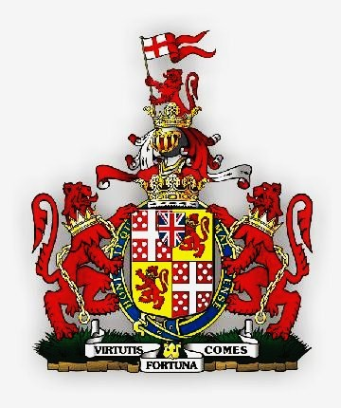

6th Annual Wellington Classic
In support of Children’s Mental Health Services
Thursday, July 5, 2018
Registration 12:30pm, Shotgun Start 1:30pm
Wellington on the Lake Golf Course
Live & Silent Auction, Dinner to follow at Wellington on the Lake Rec Ctr, Bar opens @ 4:30pm.
Format: 4 Person Scramble. Teams can be made up of any combination of men, women and children, all ages welcome! Registration deadline June 29th

9 Holes of Golf, Cart, Dinner & Wine: $80 /player (WotlGC members $60) Dinner with wine only, $25
Player 1 Please complete to receive tax receipt

Name: ___________________________________

Address: _________________________________

Phone:___________________________________

Email:___________________________________

Payment $_______ Dinner ticket(s) ______

Player 2 Please complete to receive tax receipt

Name: ___________________________________

Address: _________________________________

Phone:___________________________________

Email:___________________________________

Payment $_______ Dinner ticket(s) ______

Player 4 Please complete to receive tax receipt

Name: ___________________________________

Address: _________________________________

Phone:___________________________________

Email:___________________________________

Payment $_______ Dinner ticket(s) ______

Player 3 Please complete to receive tax receipt

Name: ___________________________________

Address: _________________________________

Phone:___________________________________

Email:___________________________________

Payment $_______ Dinner ticket(s) ______

Contact Kate at 613-399-9060 for more information, registration and dinner tickets.
Registration not completed until paid in full. Cheques payable to Children’s Mental Health Services (CHMS)

